Bradley Lamitie Active Learning Journal 5

**Description**:

The main intent of this active learning module is to solidify our understanding of how to configure a small network with VLANS. This is achieved through repeating the steps we followed in class to configure an identical network in Cisco Packet Tracer.

**Topology**:

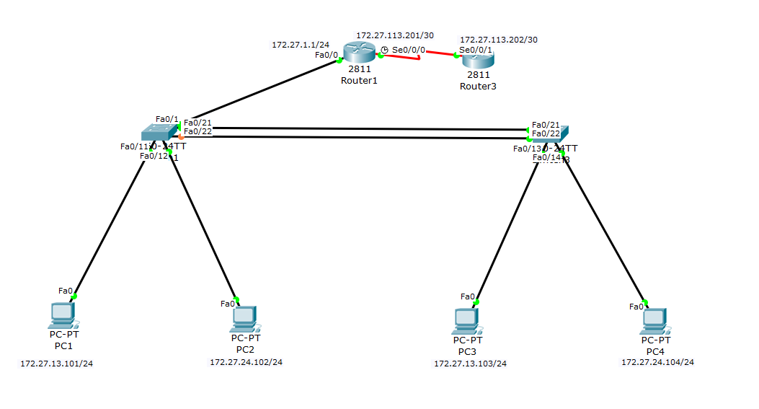

**Configuration Syntax:**

(All replaceable parameters are in italics)

|  |  |  |
| --- | --- | --- |
| **Syntax** | **Description (in my own words)** | **Mode** |
| enable | Enter privileged mode | user |
| config | Enter configuration mode | privileged |
| terminal | Configures from terminal | privileged |
| Hostname *desiredHostName* | Renames the router | Global configuration |
| Enable password *cisco* | Sets the privilege mode password to be ‘cisco’ | Global configuration |
| Ctrl + Z | Returns to privileged mode | Global configuration |
| Logging synchronous | Makes it so that the console does not create messages while you're typing a new command | Interface configuration |
| Line con *0* | Enters configuration mode for console line 0 | Global configuration |
| Password *cisco* | Sets the console line password to be ‘cisco’ | Interface configuration |
| login | Makes logging in required when accessing router from pc through console | Interface configuration |
| Interface *f0/0* | Sets the configuration mode to configure fast ethernet 0/0 port. | Global configuration |
| Ip address *ipAddress* *SubnetMask* | Configures the ip address and subnet mask for the specified interface | Interface configuration |
| No shutdown | Enables the interface | Interface configuration |
| Int *S0/0/0* | Sets the configuration mode to configure Serial slot 0/0/0 | Global configuration |
| Clock rate *64000* | Sets the clockrate of the DCE interface to be 64000 | Interface configuration |
| Show interfaces | Shows the interfaces and their stati | privileged |
| Show ip route | Shows the ip routing table | privileged |
| exit | Exits configuration mode | any |
| disable | Leaves privileged mode | Any mode above user |
| Ip route *networkAddress* *SubnetMask* *ClosestUsableIPAddress* | Creates a route in the routers routing table | Global configuration |
| Line vty 0 4 | Selects the first 5 virtual terminal lines | Global configuration |
| Copy running-config startup-config | Copys the running configuration to a file that runs on startup. | Global configuration |
| Router rip | Sets the router to use RIP | Global configuration |
| Version 2 | Sets the version of rip to version 2 | Router Configuration |
| Network *classical address* | Sets the network to use with RIP | Router Configuration |
| Show ip protocol | Shows information about the current protocol on your router | privileged |
| No Ip route *networkAddress* *SubnetMask* *ClosestUsableIPAddress* | Gets rid of a static route in the routing table | Global configuration |
| Show ip int brief | Displays interfaces in a shorter format than show interfaces. | privileged |
| Router OSPF 1 | Enters router configuration mode using ospf routing | Global configuration |
| Network *networkAddress WildcardSubnetMask* area *areaNumber* | Tells OSPF which network to broadcast | Router configuration |
| Do *Command* | Executes a command in the appropriate mode and return back to the current mode were in | Any mode |
| Show ip ospf interface | Shows all interfaces ospf is configured on | Privileged mode |
| Ipv6 unicast-routing | Forwards from a source to a network | Global Configuration mode |
| Ipv6 address *ipv6address* / *SubnetMask* | Configures an ipv6 address for a given interface | Interface Configuration Mode |
| Ipv6 route *networkAddress* / *SubnetMask* *ipv6address* | Configures a static route for ipv6 | Global configuration Mode |
| Ipv6 router rip ripng | Sets the router up in the RIP protocol | Global configuration Mode |
| Ipv6 rip RIPNG enable | Enables the interface to use ripng | Interface configuration mode |
| Ipv6 router ospf 1 | Sets the router up in the OSPF protocol | Global configuration Mode |
| Ipv6 ospf 1 area 0 | Enables the interface to use ospf | Interface configuration mode |
| Ipv6 router eigrp 307 | Sets the router up in the EIGRP protocol | Global configuration Mode |
| Ipv6 eigrp 307 | Enables the interface to use ospf | Interface configuration mode |
| Ipv6 ::/0 *interface* | Creates a default static route | Global configuration Mode |
| Enable exec-timeout 0 0 | Enables the line to never time out | Line configuration Mode |
| Vtp mode server | Sets the device to act as a server | Global configuration Mode |
| Vtp domain *domainName* | Sets the domain name | Global configuration Mode |
| Vtp password cisco | Sets the password to cisco | Global configuration Mode |
| Vlan *vlanNnumber* | Enters the vlan specified | Global configuration Mode |
| Name *name* | Names the vlan | VLan configuration mode |
| Switchport mode access | Sets the interface as a access port | Interface configuration mode |
| Switchport access vlan *vlanNumber* | Selects the vlan that can be accessed | Interface configuration mode |
| Switchport trunk encapsulation dot1q | Used only in switch model 3560 | Interface configuration mode |
| Switchport mode trunk | Sets the switchport mode to trunk | Interface configuration mode |
| Vtp mode client | Sets the switch to be the client | Global configuration mode |
| Show vlan | Show all vlans | Privileged mode |
| Show interface trunk | Shows all interfaces enabled with trunk | Privileged mode |
| Show vtp status | Shows the status of vtp | Privileged mode |

**b)**

**Status:**

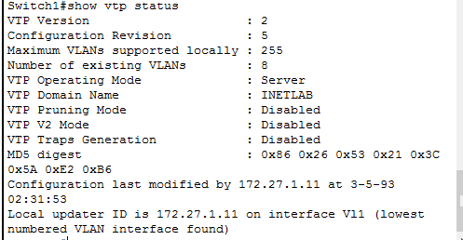

**Vlans:**

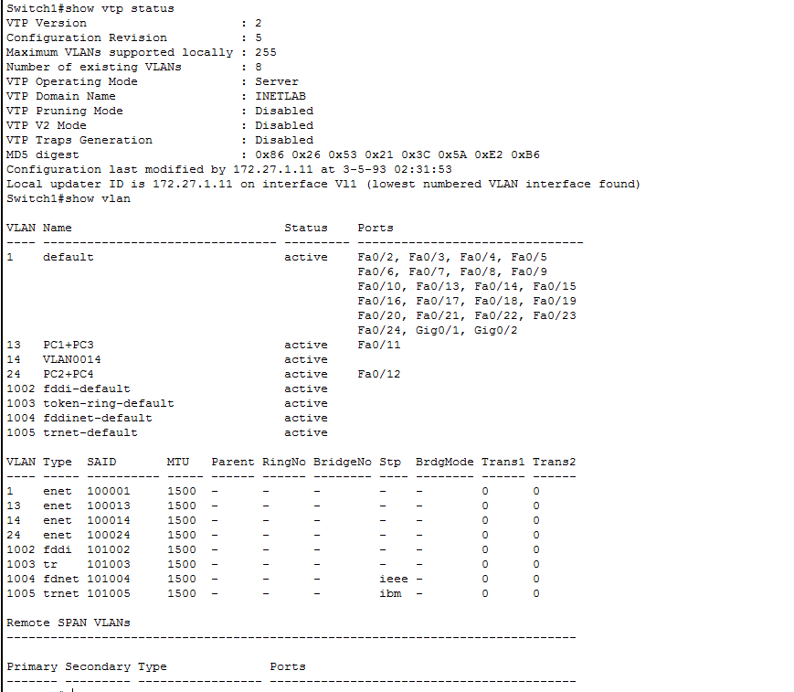

**Interfaces:**

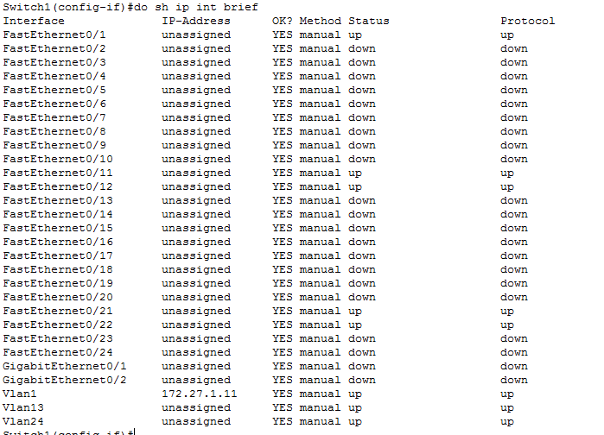

**c)**

**Status:**

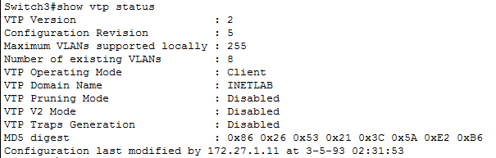

**Vlans:**

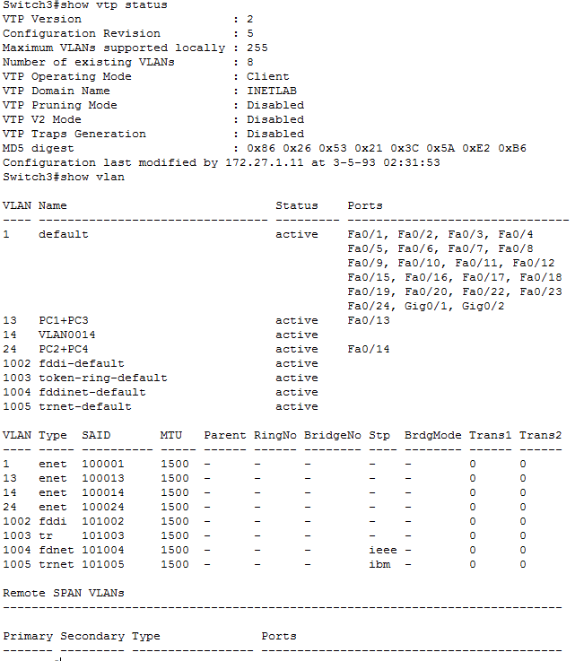

**Interfaces:**

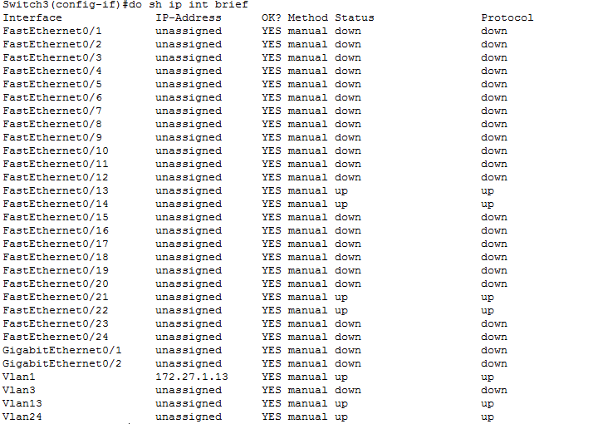

**Trunk interfaces:**

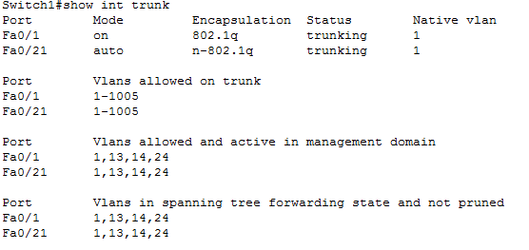

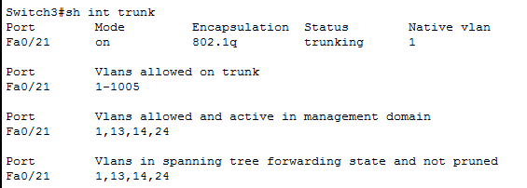

**d)**

**interfaces**

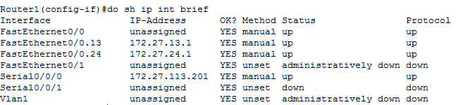

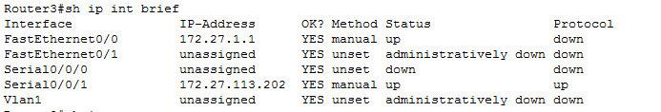

**Routing table:**

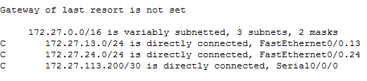

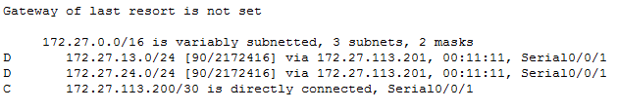

**Verification:**

**Pc1:**

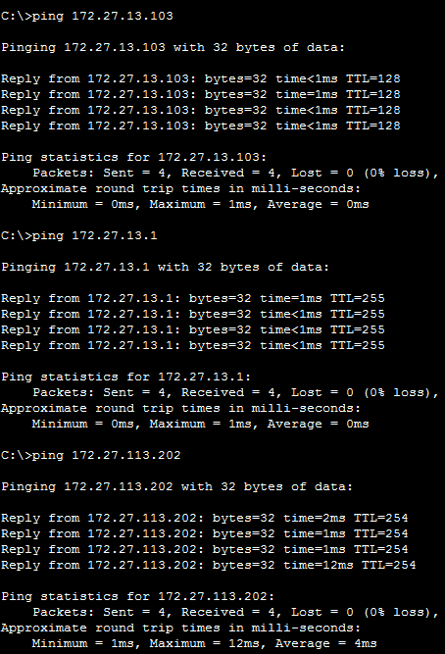

**Pc2:**

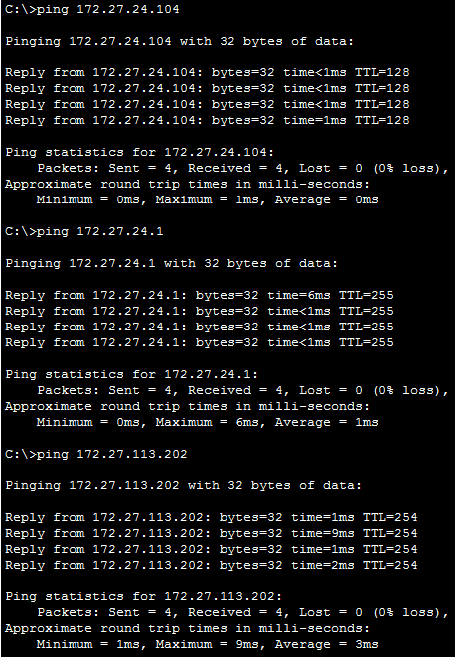

**Pc3:**

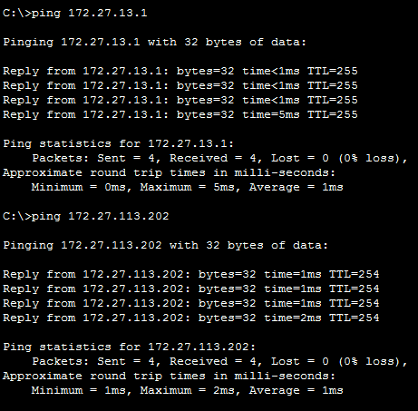

**Pc4:**

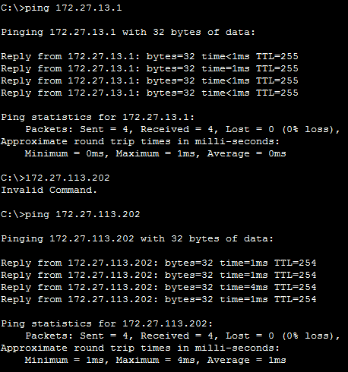

**Troubleshooting Syntax:**

I didn't have any problems this time.

**What Worked, What Didn’t?:**

Everything worked fine.